POLISH STUDENTS
IN BELGIUM

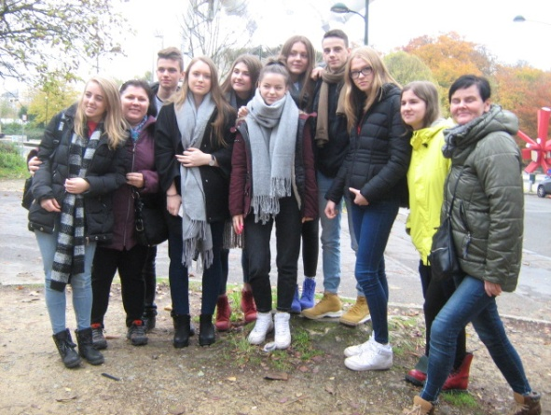
We are young people, who want to broad the horizons. We love travelling, meeting new cultures and making new friends. We had an opportunity to visit Belgium, because we are taking part in European project called ‘Erasmus+ Paths of Europe’. Our school cooperates with schools from Belgium, Spain and Italy. We were selected from students from our school. We represented II LO im. Marii Skłodowskiej-Curie w Końskich
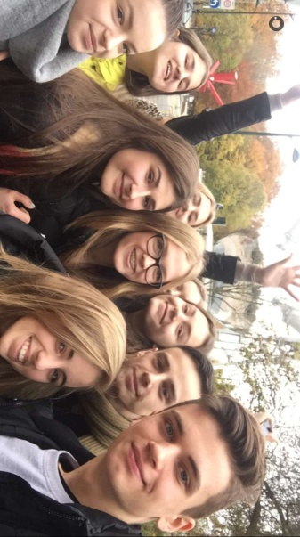
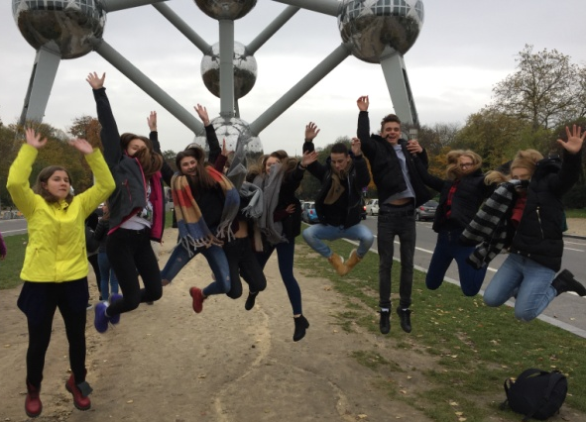
on the first meeting in Hasselt in Belgium. We spent the whole week with our exchange-students and their families. We met their typical day at school, everyday routine and habitats at home. We also had a chance to try traditional Belgium dishes during dinners with our host-families. We would like to tell you something more about our trip end experiences, so we wrote a diary
from Belgium. We hope you will like it.

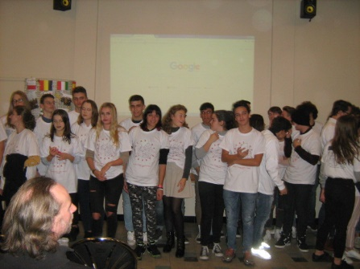
DAY 1: Monday 13th November
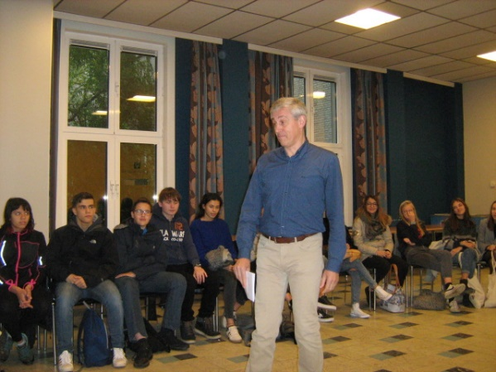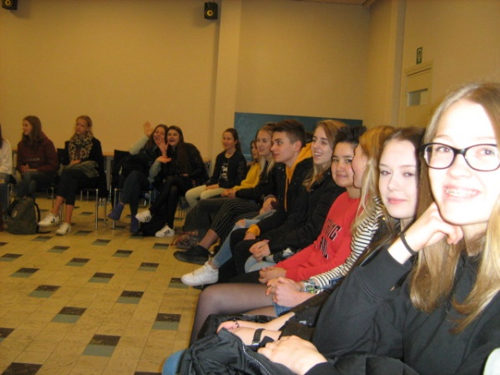

Our activities at school started at 8:30, because this is an ordinary time when school starts. First of all we were welcomed at school and we met the plan of the whole project. We during school-tour we could meet and talk to students from another countries. We got some knowledge about language at Dutch class. We also sang a song in Dutch, which is called ‘Vrolijke vrienden’. After that we had presentations about our countries.

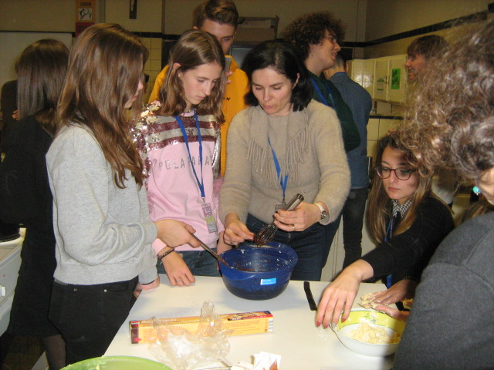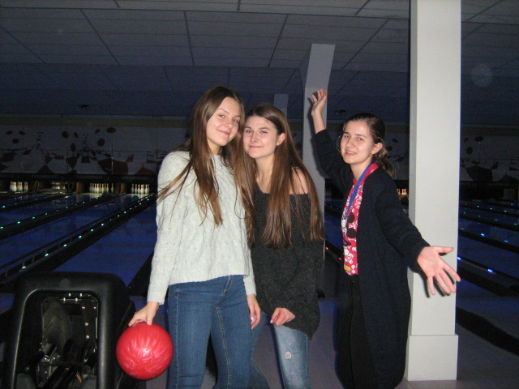
This day at school ended with cooking workshops. We prepared traditional Belgian waffles and truffles. After dinner with host-families we spent nice evening on bowling.

DAY2: Tuesday 14th November
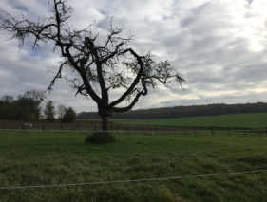
Tuesday was very active day, suitable for people who like sport activities. In the morning we started our hiking day. We were walking from Aldek Biesen to Tongeren. Distance has 15 KILOMETERS long, so it was very long way. During departure we could see Belgian landscape. After hiking we visited the oldest town in Belgium- Tongeren. In the evening we supported Belgium national football team, which play with Japan. The match ended the win of Belgian.

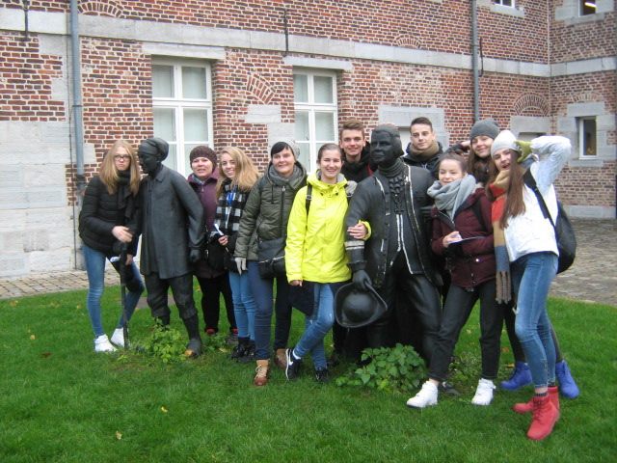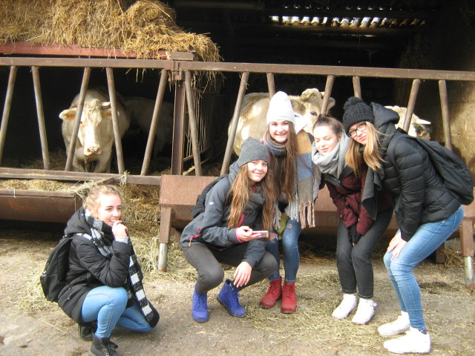

DAY 3: Wednesday 15th November
To start the day we saw the performance of English theatre group. It was criminal comedy. It's a pity that we couldn't be on the start of the play. But what we saw was still awesome (not only for students but also for teachers). After the performance we went to the city centre. When we were walking through Hasselt's street, we could see the beauty of this Belgian town. My friends and I were really enjoying the organizers' idea for spending time together. We had to find some of Hasselt's sculptures. In this way we could get to know some of Belgium's culture. After few hours in the city we had a free time to spend some with our host's families. I know from my friends that they spent great time with their new Belgian family. By the end of day we went to the Jumpsquare. It wasn't in project's programme but it was awesome, so I thought that I should tell something about it.
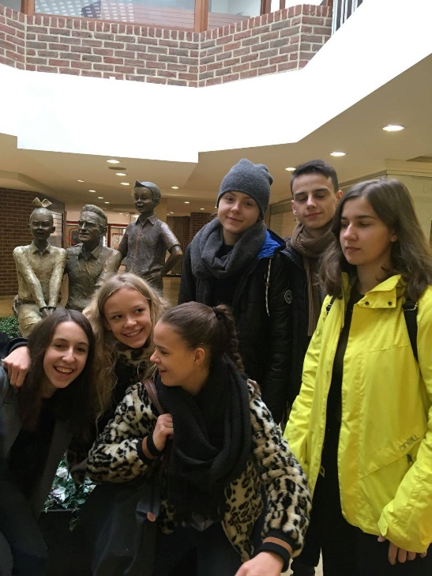
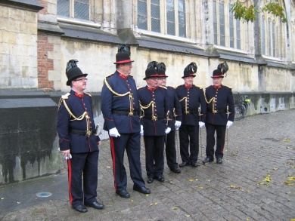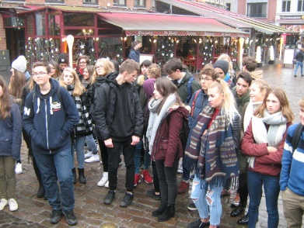

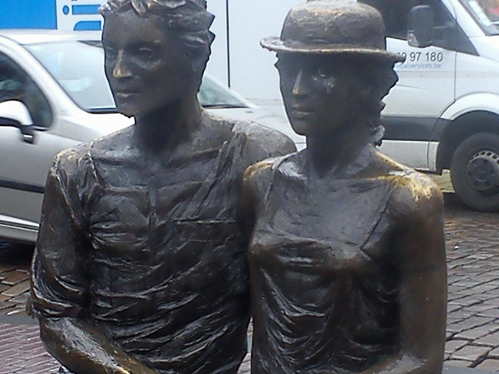
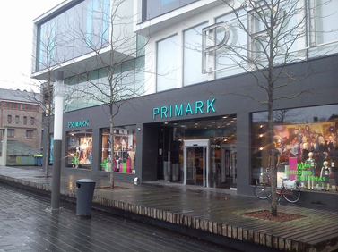

DAY 4: Thursday 16th November
Thursday was a day, when we went together on a tour of Brussels. We left very early and first point of our trip was Atomium.
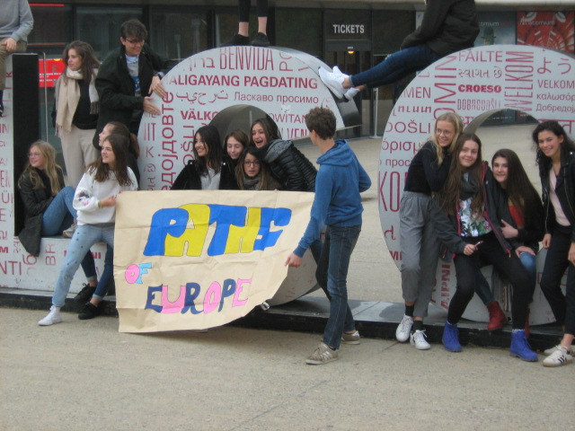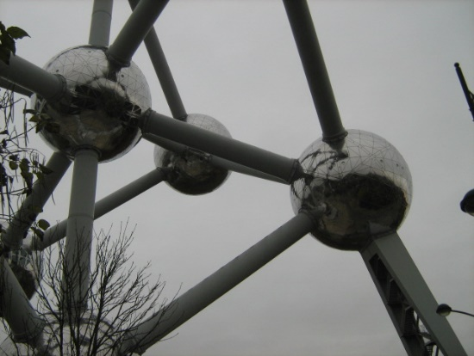
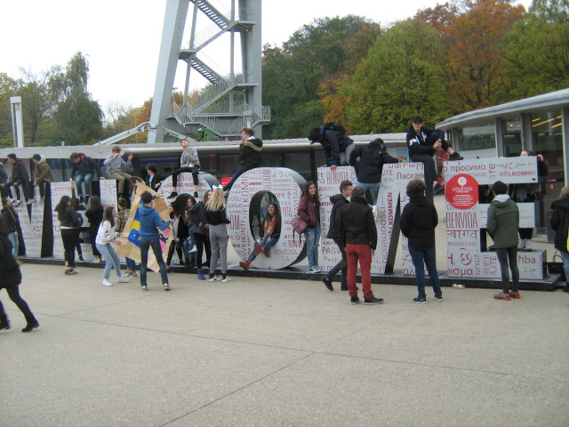
It was a very impressive and absolutely worth visiting place. After that, we went to the centre of Brussels. We also had some educational exercises connected with sightseeing the city. We had an opportunity to see the Grand Place, Royal Palace of Brussels, Manneken Pis and much, much more. Me and my friends really enjoyed sightseeing this huge, beautiful and modern city. At the end of the day we had a dinner together at the restaurant in Hasselt.
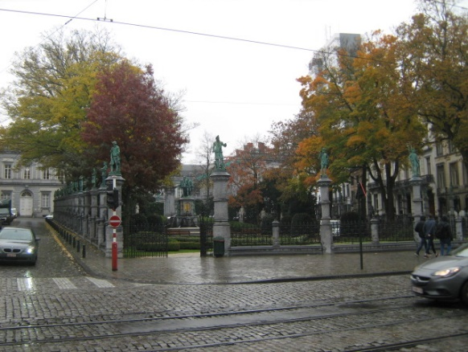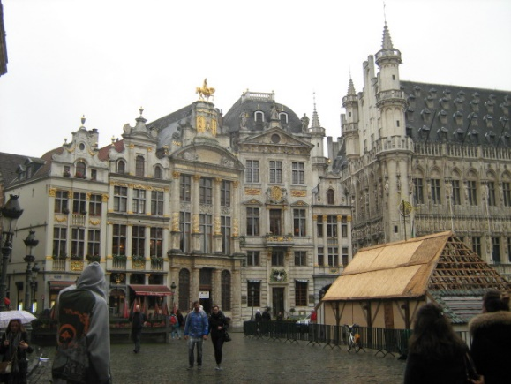
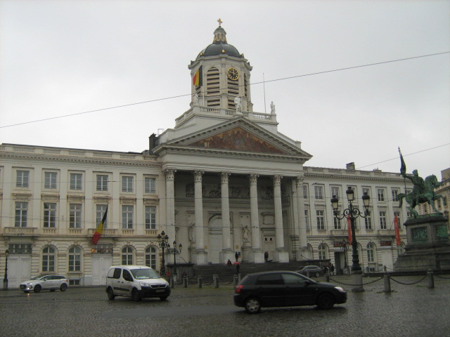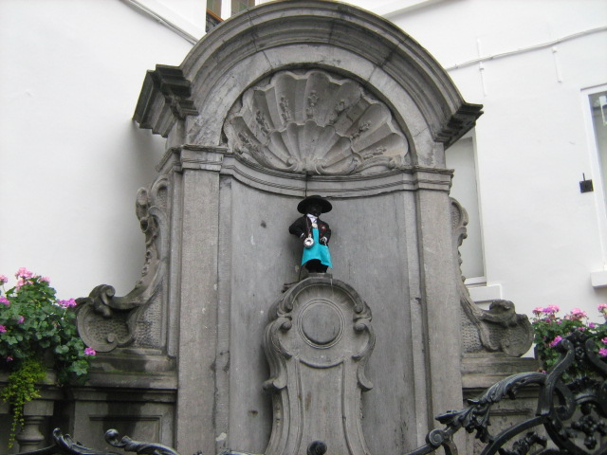

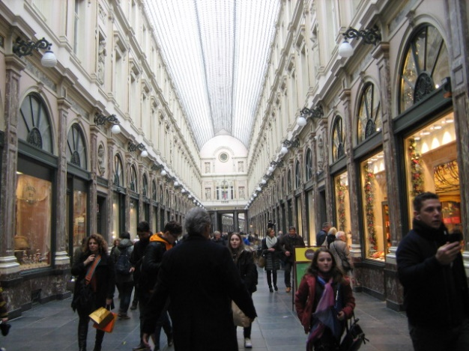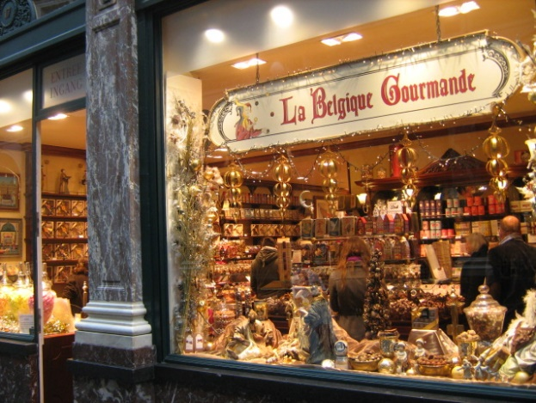

DAY 5: Friday 17th November
Friday was the last day of our visit in Belgium. We were doing many workshops for the project, so we didn't have time for ourselves. We made decorations, presentation and other things for a goodbye party. Whole day was rather a work than fun. But this way we could spend some time more with each other. For some relax we had something like music lesson. That was a first time when I played piano. It was terrible but I don't really care about it. After making our party preparations done we had free time for packing, eating dinner etc. At 19:30 the Grande Finale started. It was pretty emotional event. We were laughing, crying and talking until midnight. It was the end of one of biggest adventures of our lives.
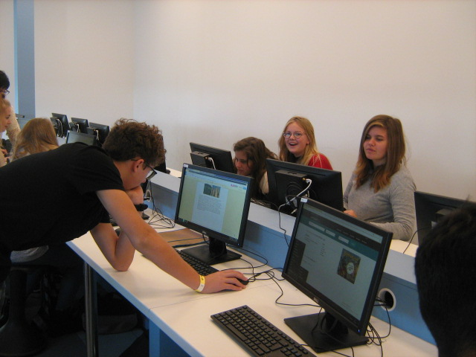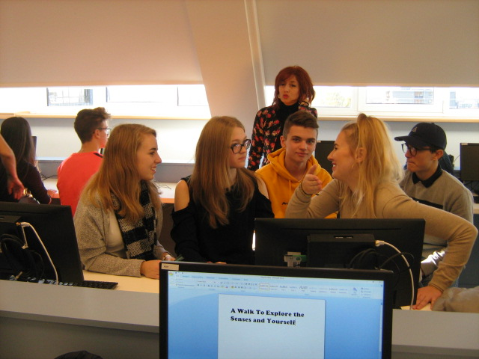
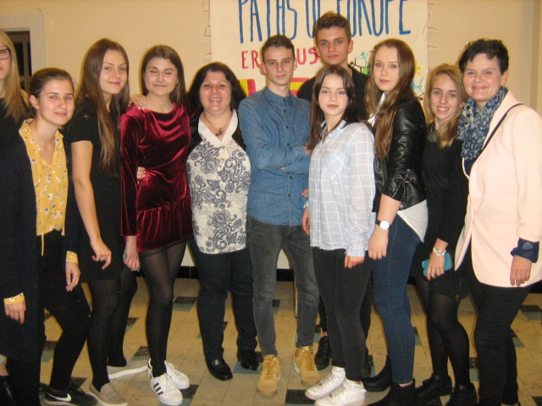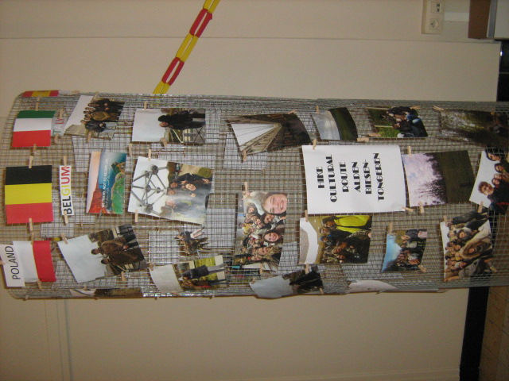

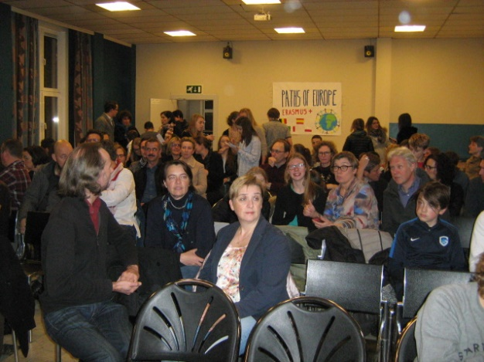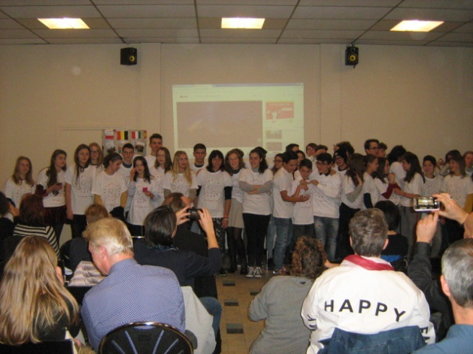

To sum up we had a great time in Belgium. Our dream came true and we met friends for life. That kind of project make strong relations between us and hosts. We are really impressed and thankful for hospitality. We strongly recommend taking part in projects like that. The only thing which was imperfect was too little of time. It was so sad to go back, but now we are looking forward to see our host at our place in Końskie in September.

