MEETING IN ANDERNACH GERMANY
23rd – 27th October 2017

Monday, 23rd October 2017

On the first day students were welcomed with some icebreaker games. Everybody was having fun. Then we started doing our first task. Working in national groups we had to draw a suitcase with useful things in it. But all of these items had to symbolize something and show expectations and aims of the project. We also voted for the best logo of the projectThen the students (in international groups) went on a trip to Andernach. We were looking for answers to the questions which we had been given by our coordinators.
After the lessons some of us went to Andernach again to see the Gaysir.

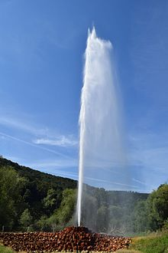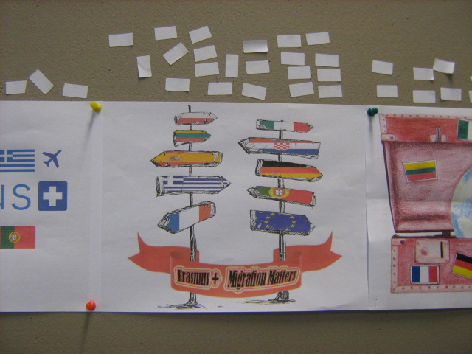

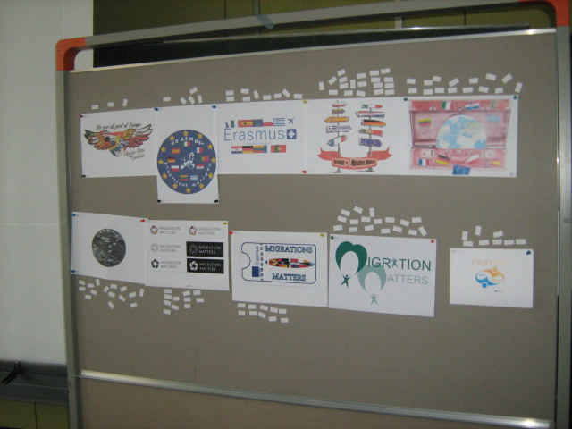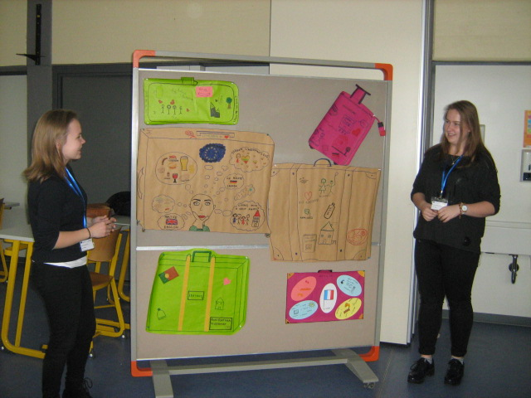

Tuesday, 24th October 2017

In the morning we got our new tasks. We had to prepare some interviews. Every group had to ask some questions to migrants (mostly the teachers from the school in Andernach). Then we showed the results in the form of multimedia presentations or posters.
After lunch (prepared by our teachers and coordinators) students spent a few hours in Kandi Turm, one of the biggest local sports centers. Some of us went climbing and others played badminton. It was an amazing experience.

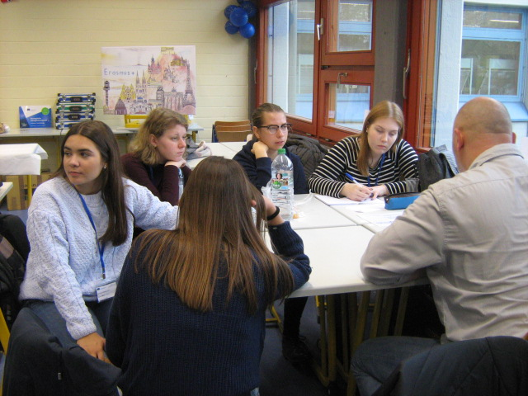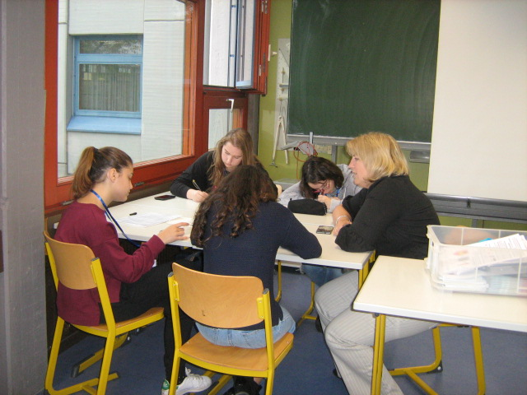

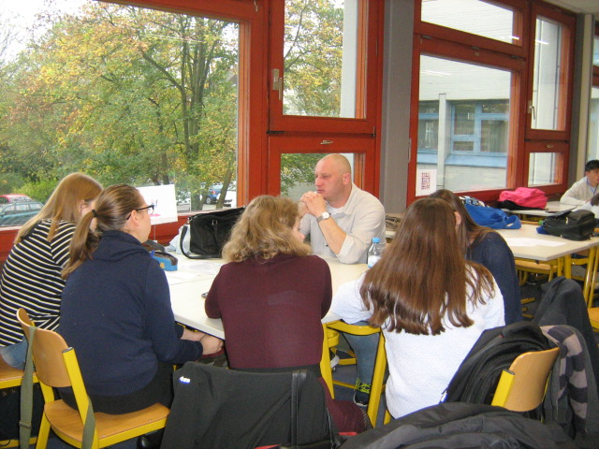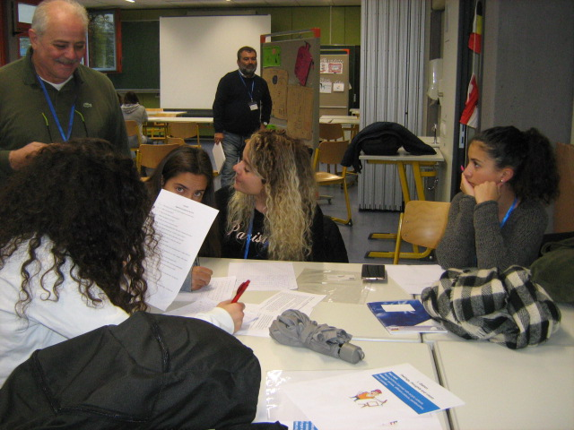

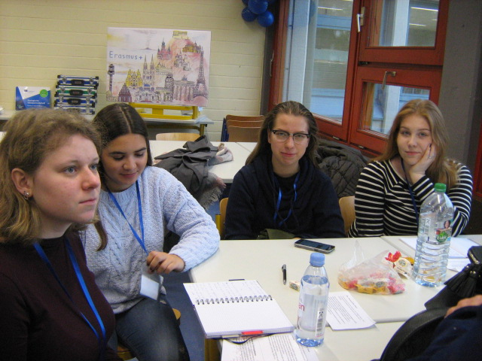
Wednesday, 25th October 2017

All the students, working in groups, created something connected with migrations. The first group painted posters presenting the situation of migrants. The second wrote a song about migrations. The third made a model and a sculpture. The last group drew a map showing the main directions of migrations all over the world.

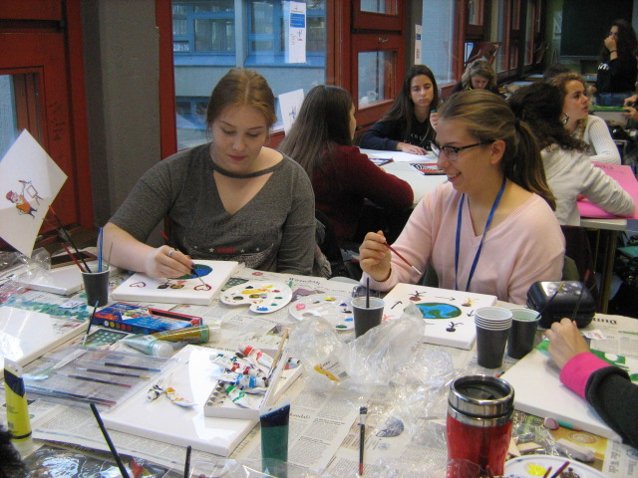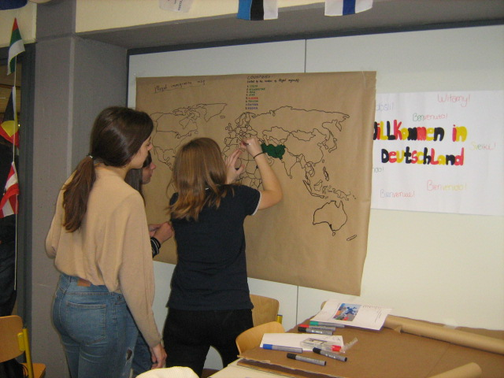

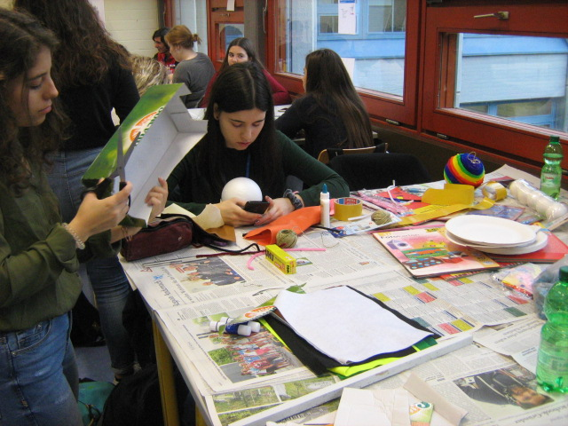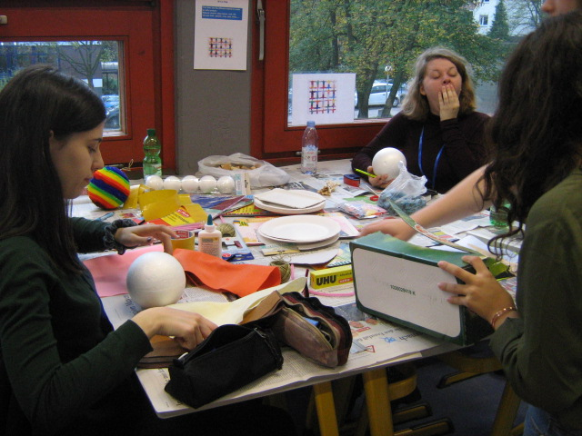

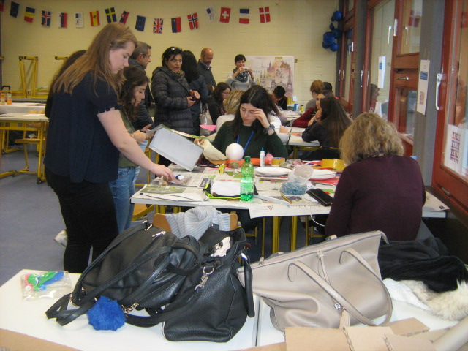

Thursday, 26th October 2017

In the morning we had some time to finish the silhouettes whose preparation had been started before the meeting in Germany.
Then students and the teachers went together on a trip to Cochem, a beautiful town near Andernach. We all visited a beautiful castle. The building is so impressive! After the tour of the castle we went on a boat trip down the Moselle River. The last part of that day was a dinner in a restaurant. We had a chance to taste some of the most popular traditional German dishes.

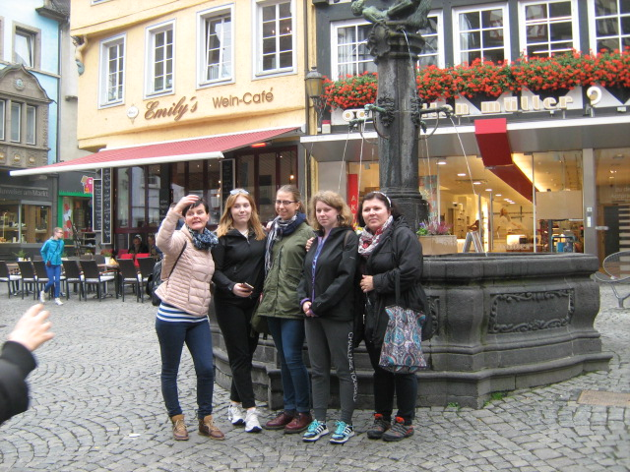

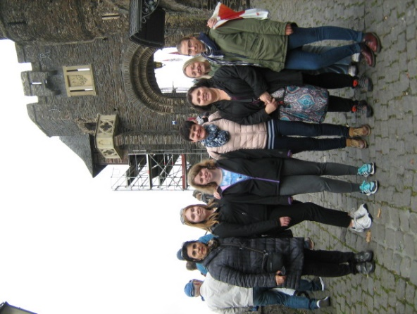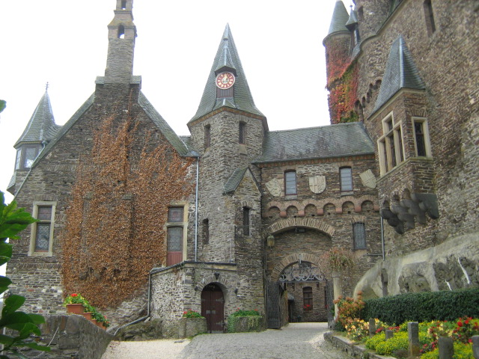

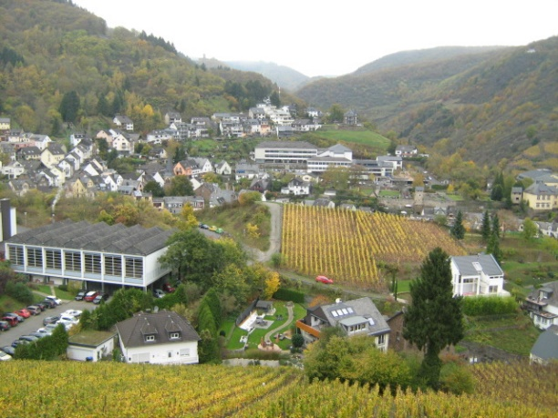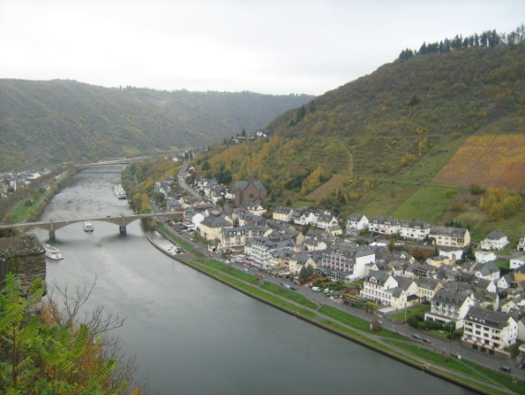

Friday, 27th October 2017

That day we presented the results of our group work during the project. Later we went to Andernach to meet the mayor of the town. He told us some interesting facts from the history of the town and migrants who live in Andernach. Students could talk to him and ask him any questions they wanted.
In the evening our coordinators organized a farewell party for all the students. Everybody was dancing and having fun. Then we had to say good bye to each other and go to our host families' houses.

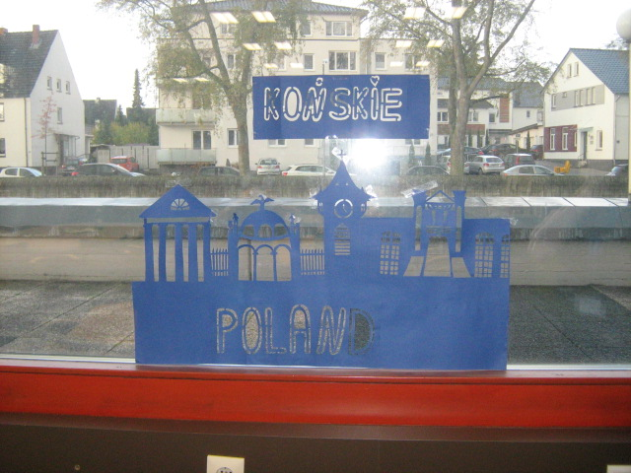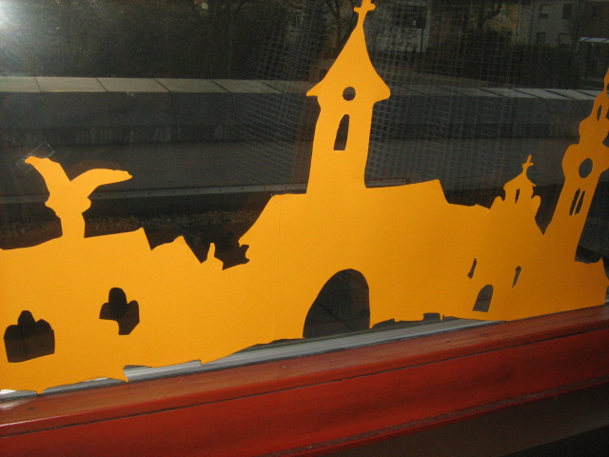

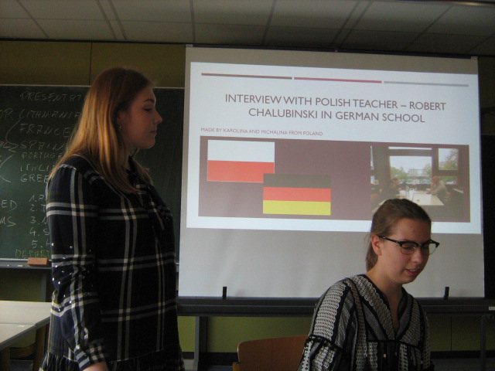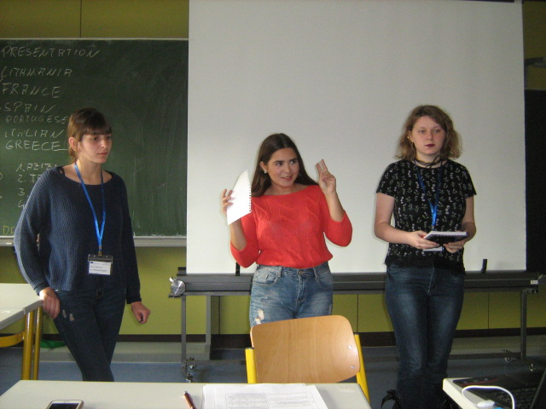

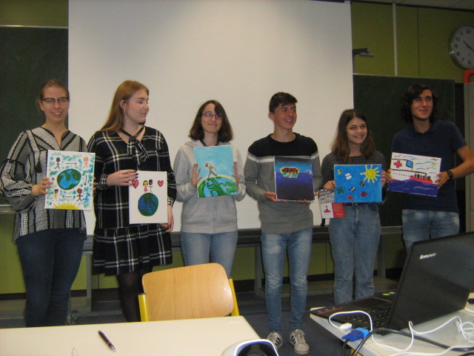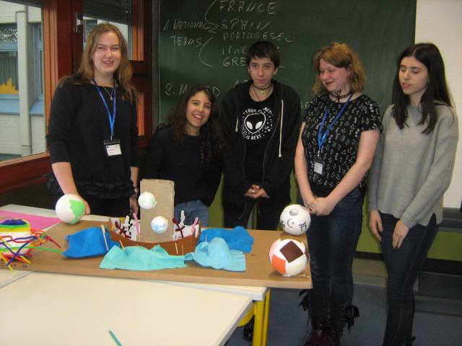
The meeting in Andernach was an amazing experience for all of us!!!

